**IS 698 Special Topics in Information Systems**

**Lab 1c**

**Securing AWS Environment for Workload Migration**

**Part 1: Create IAM Roles for Developers**

**Step 1.2: Define Trusted Entity**

**AWS service – EC2**

**Attached AmazonS3ReadOnlyAccess**

**Role name: DeveloperRole**

**Step 1.4: Review and Create**

**Part 2: Define IAM Policies**

**Step 2.1: Create a Custom Policy**

Navigate to **IAM Policies** and click **Create policy**.

Define permissions in JSON format:

**Review policy: S3FullAccess is created**

**Step 2.2: Attach Policy to a Role or User**

**The policy is attached to the developer role**

**Part 3: Secure Access with MFA**

**MFA was already added to the root user**

**Step 3.2: Enable MFA for IAM Users**

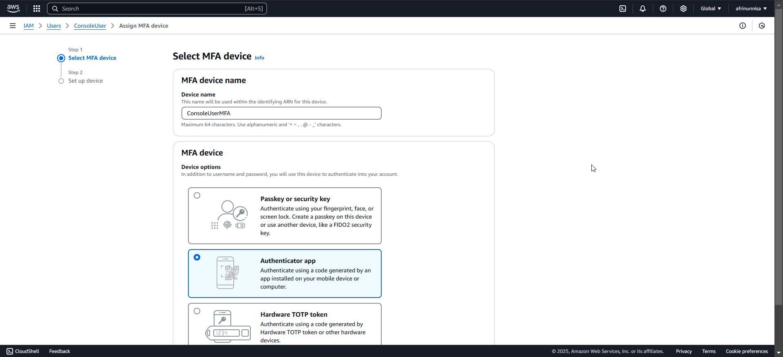

**Part 4: Test Access**

**Testing the MFA access for ConsoleUser**

Log in as the developer to the AWS Management Console or AWS CLI.\n2. Verify the roles and policies applied:

